**OUTPUT SCREENSHOTS**

1.HOME PAGE:

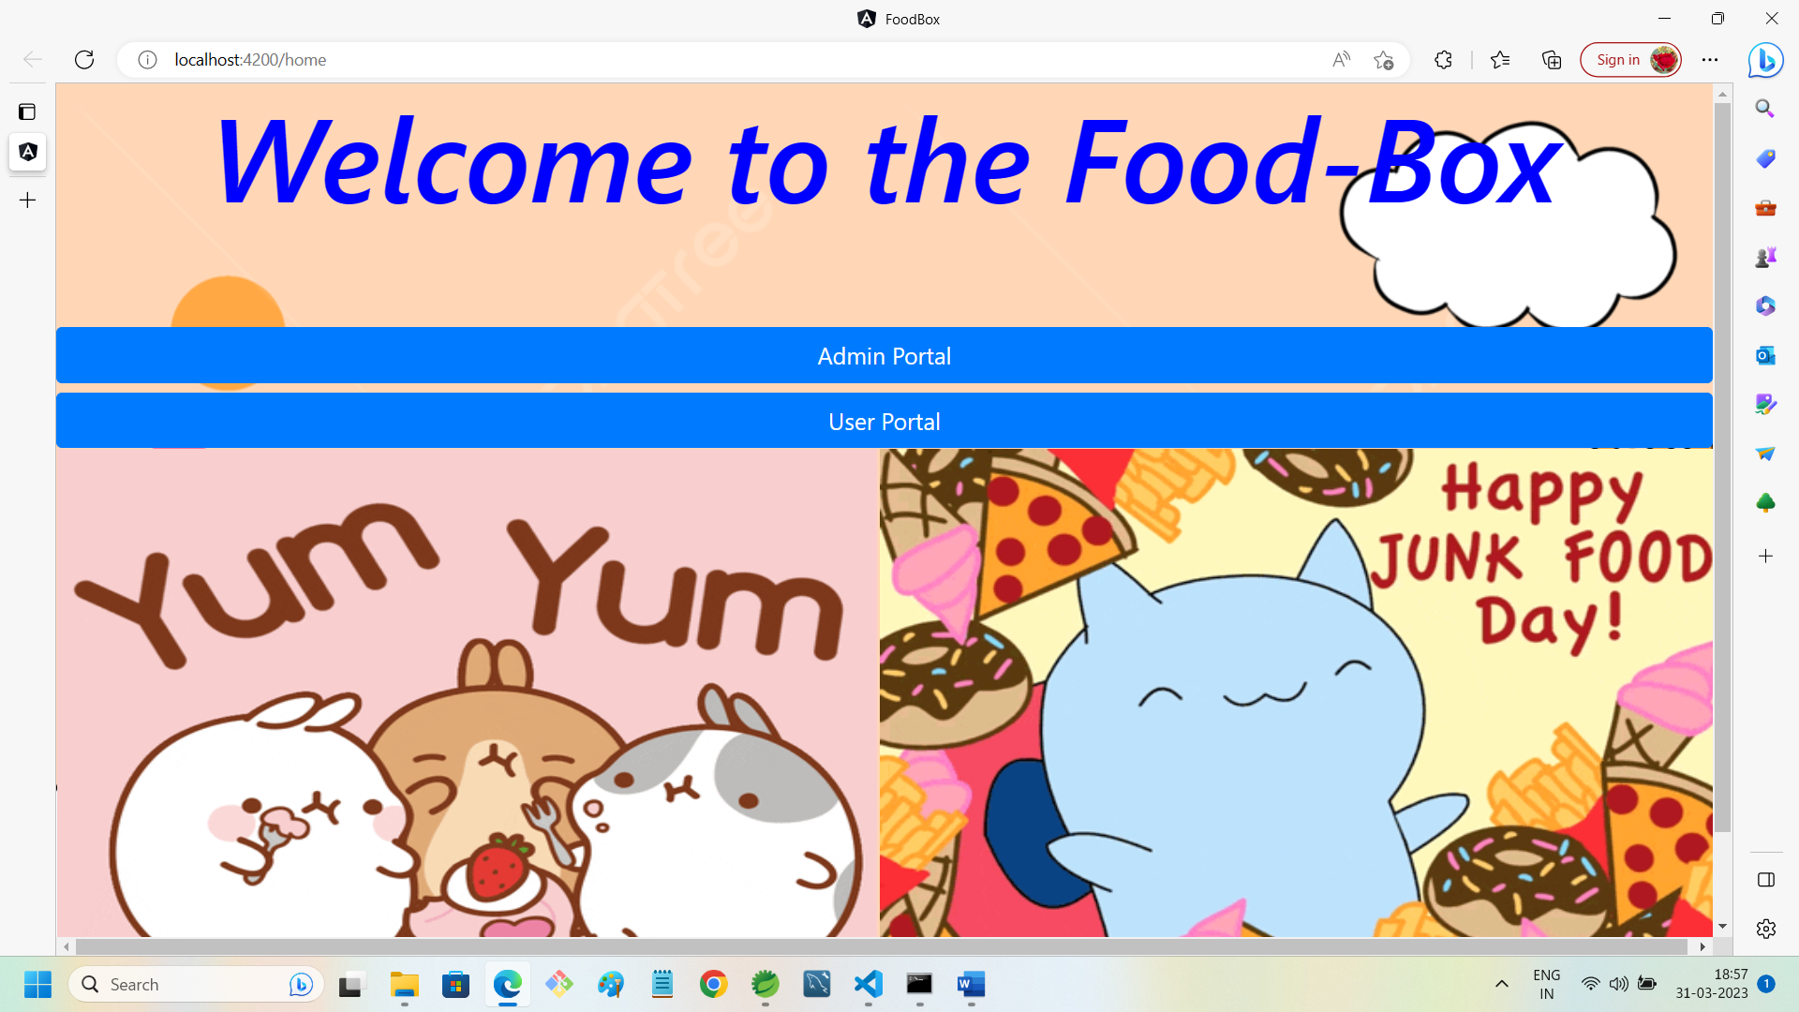

**2.ADMIN PORTAL WITH SLIDE IMAGE1:**

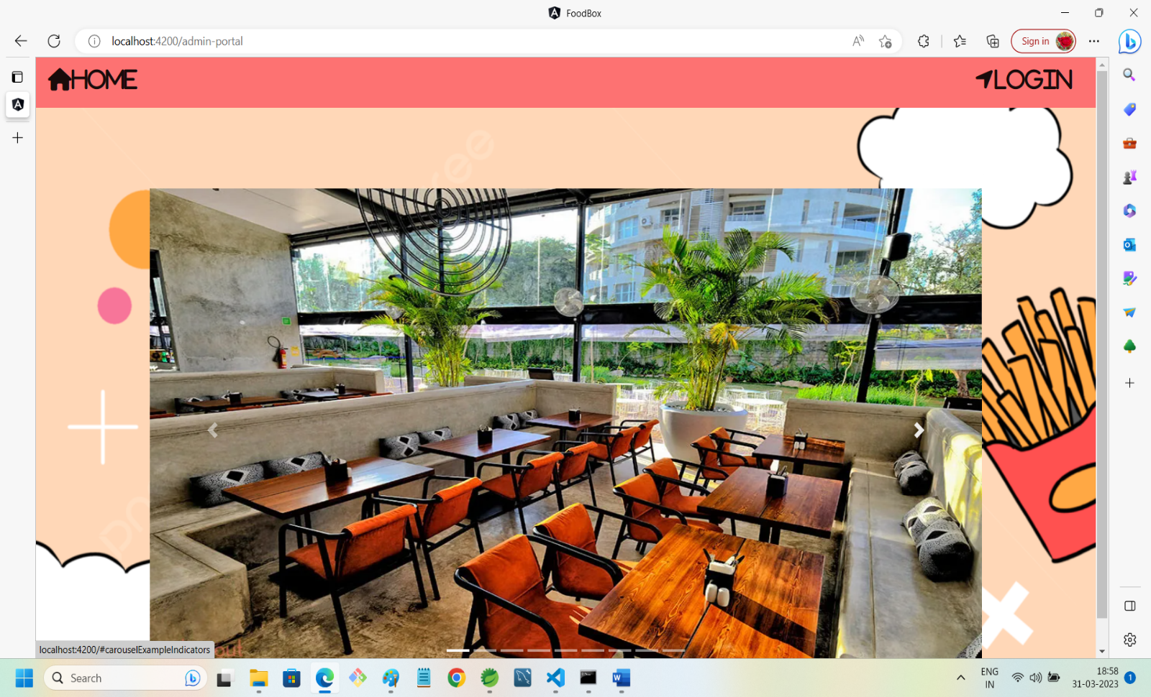

3. **ADMIN PORTAL WITH SLIDE IMAGE2:**

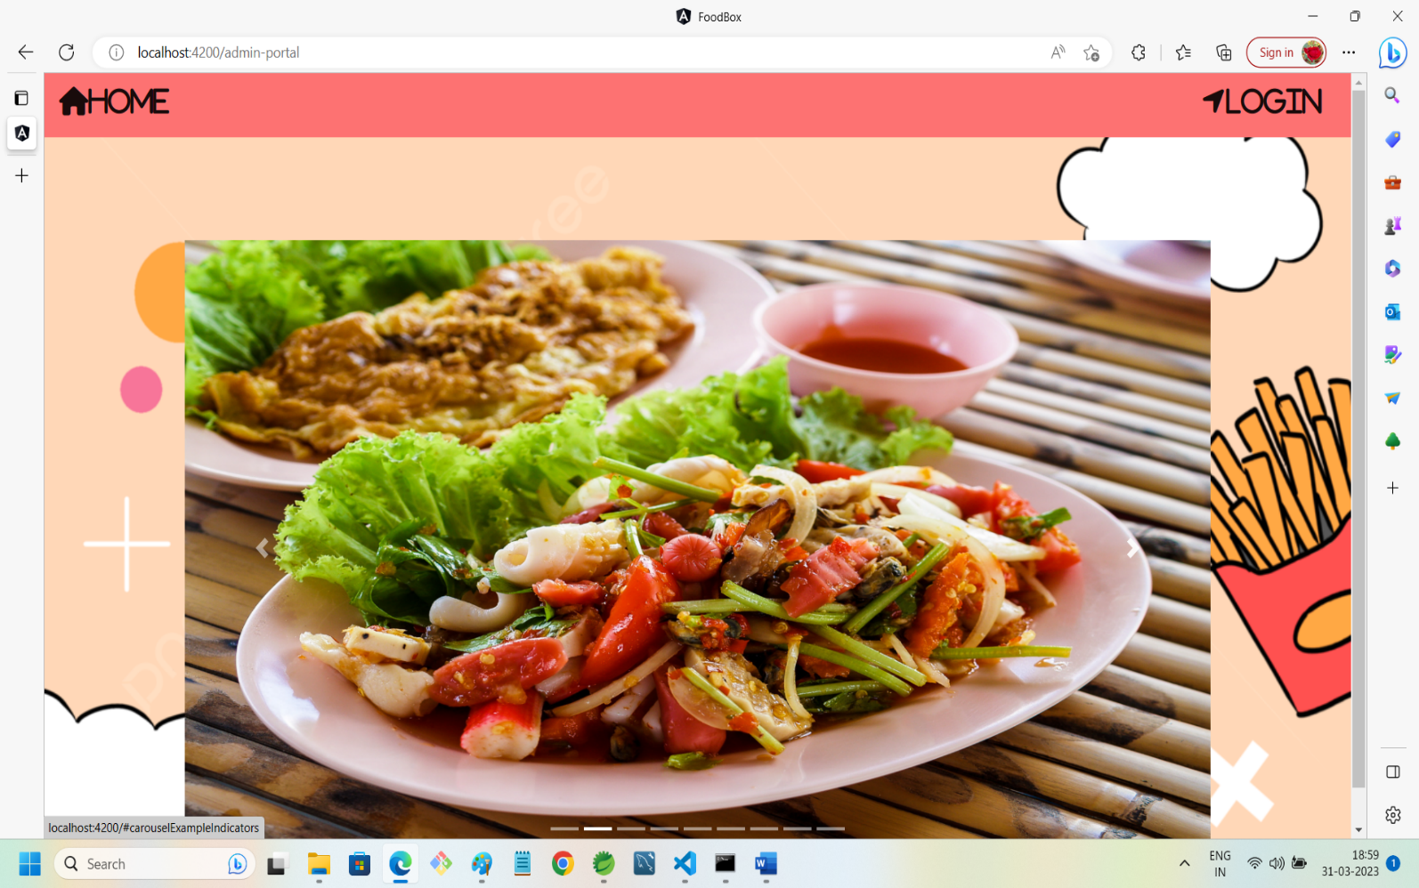

4. **ADMIN PORTAL WITH SLIDE IMAGE3:**

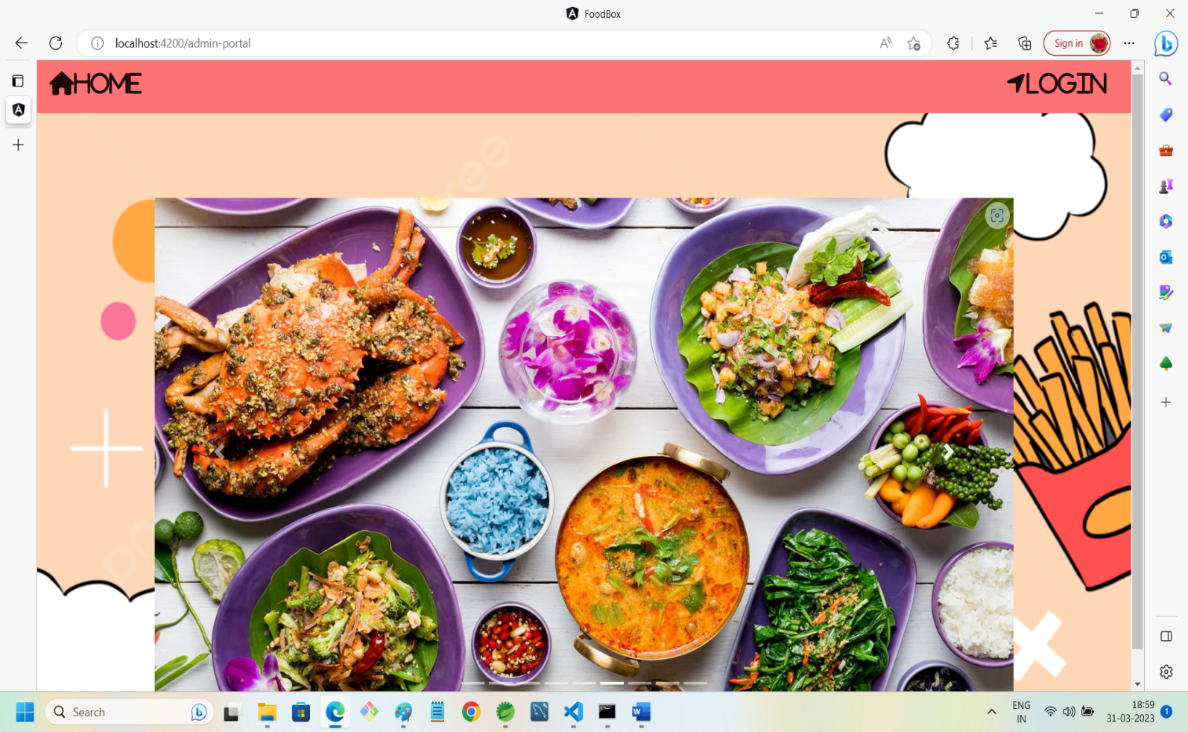

5. ADMIN LOGIN SECTION:

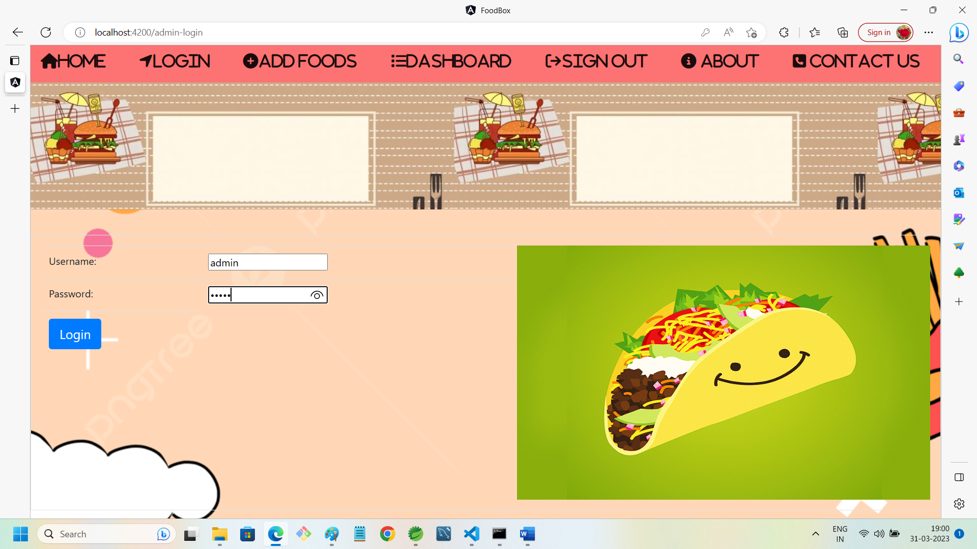

6.ADMIN DASHBOARD AFTER ENTERING VALID CREDENTIALS:

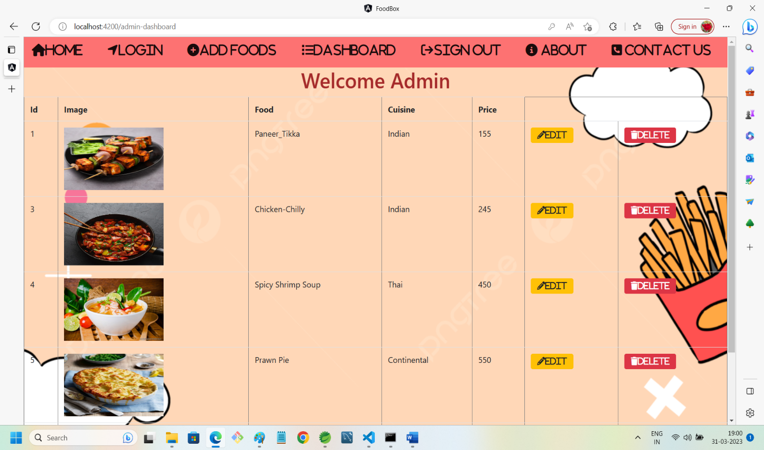

7.ADMIN CAN EDIT FOOD DETAIL:

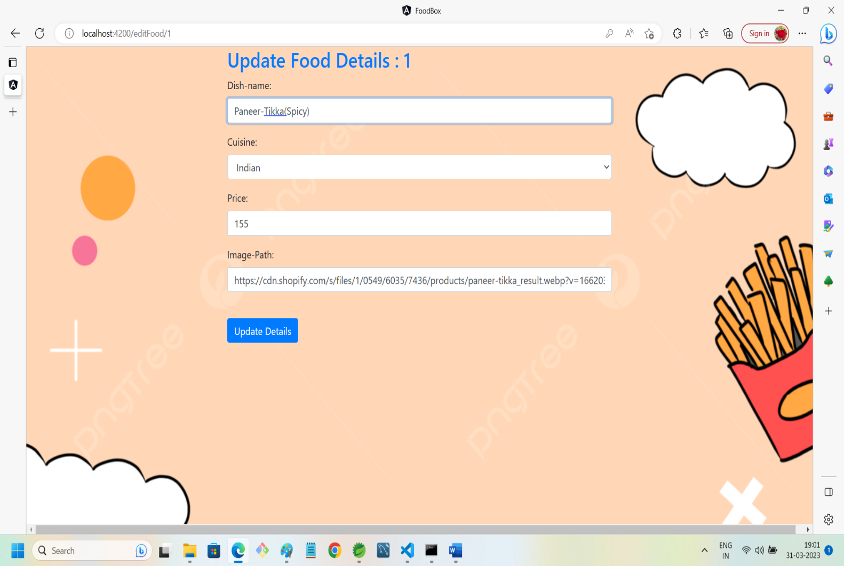

8.DATA UPDATED SUCCESSFULLY:

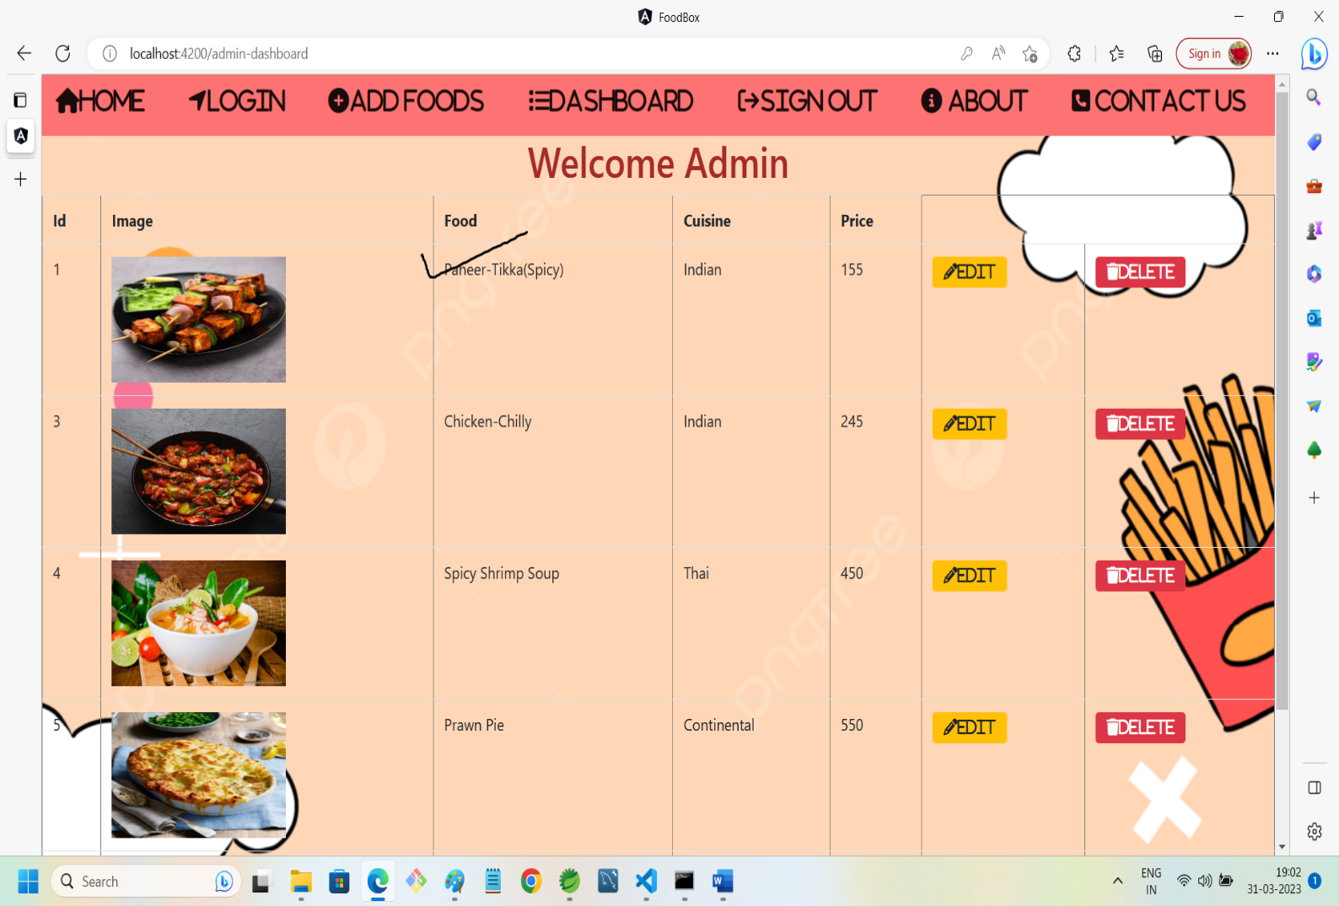

9.ADD FOOD:

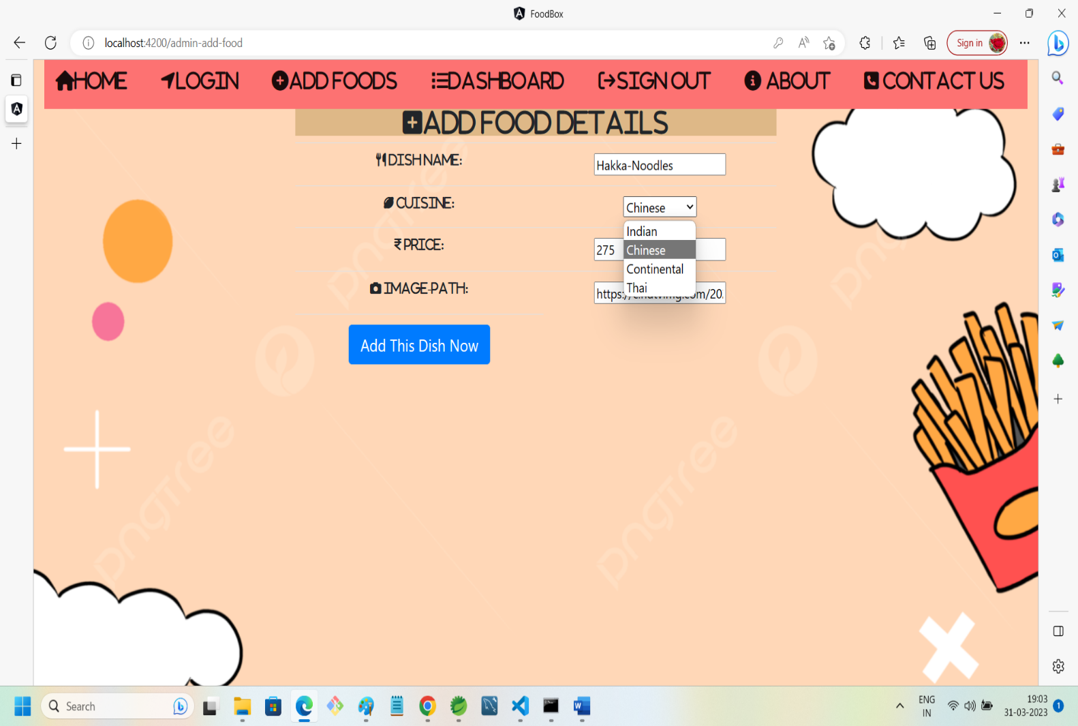

10.DATA ADDED SUCCESSFULLY:

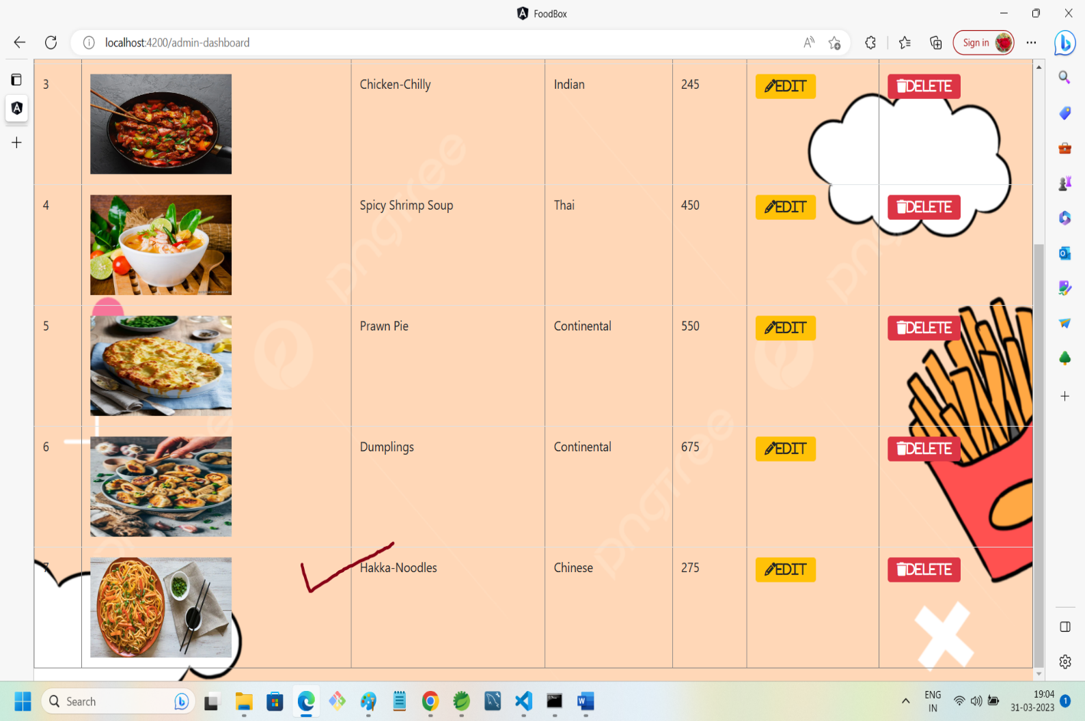

11.ABOUT US SECTION:

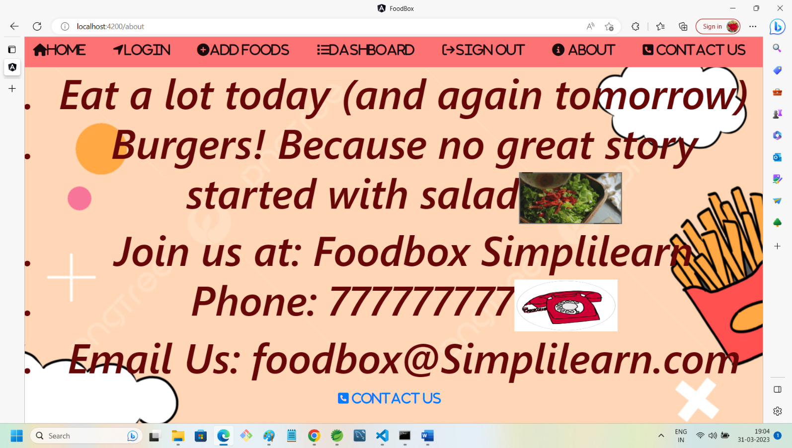

12.CONTACT US SECTION:

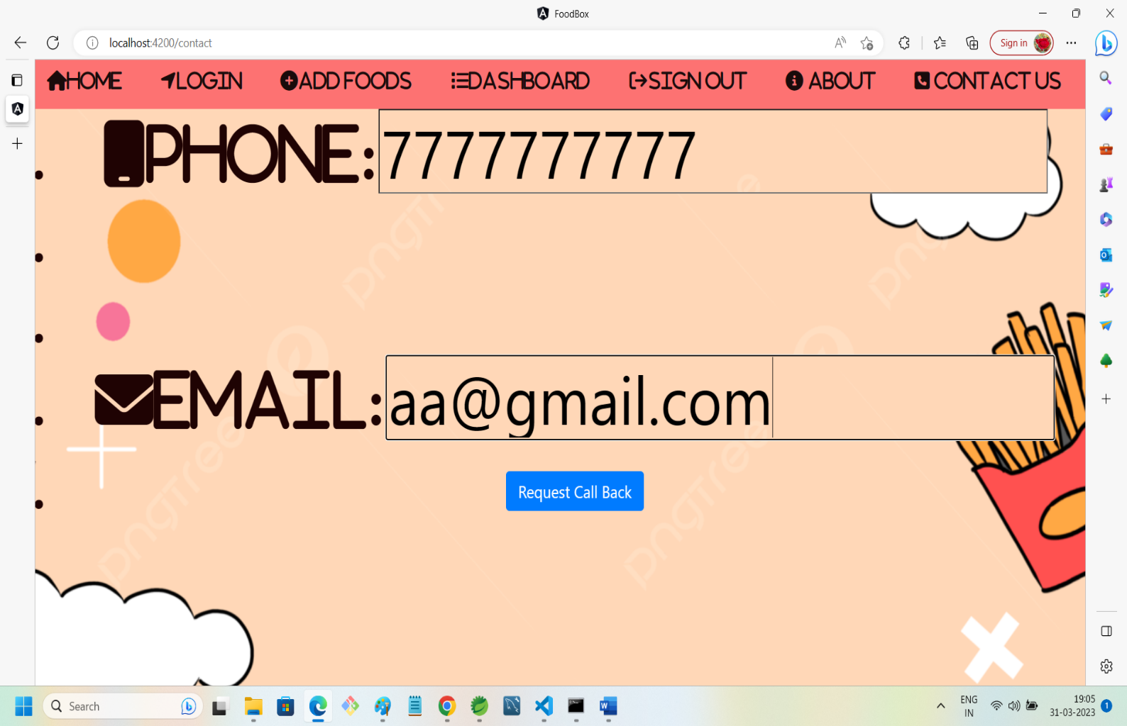

13.SIGN OUT ADMIN:

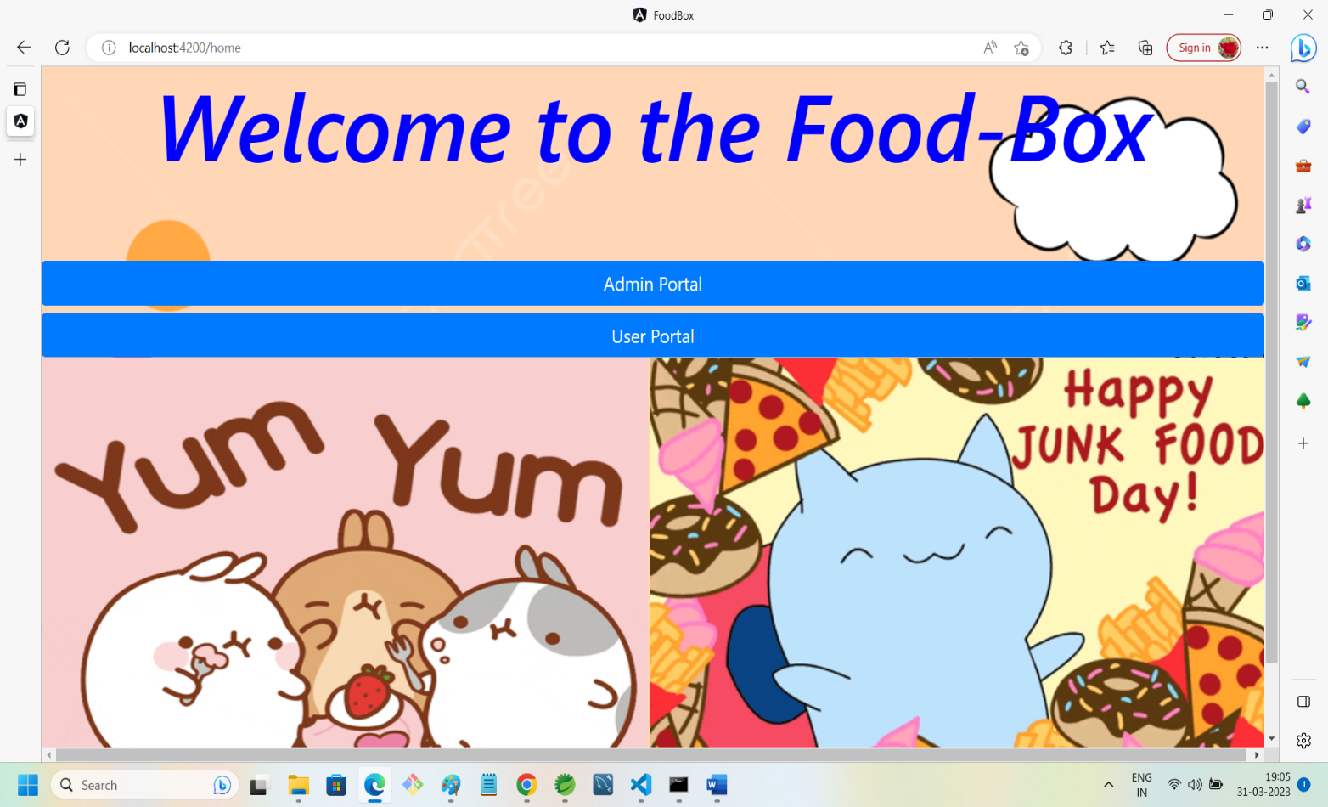

14.USER FRONT PAGE WITH BUY BUTTONS:

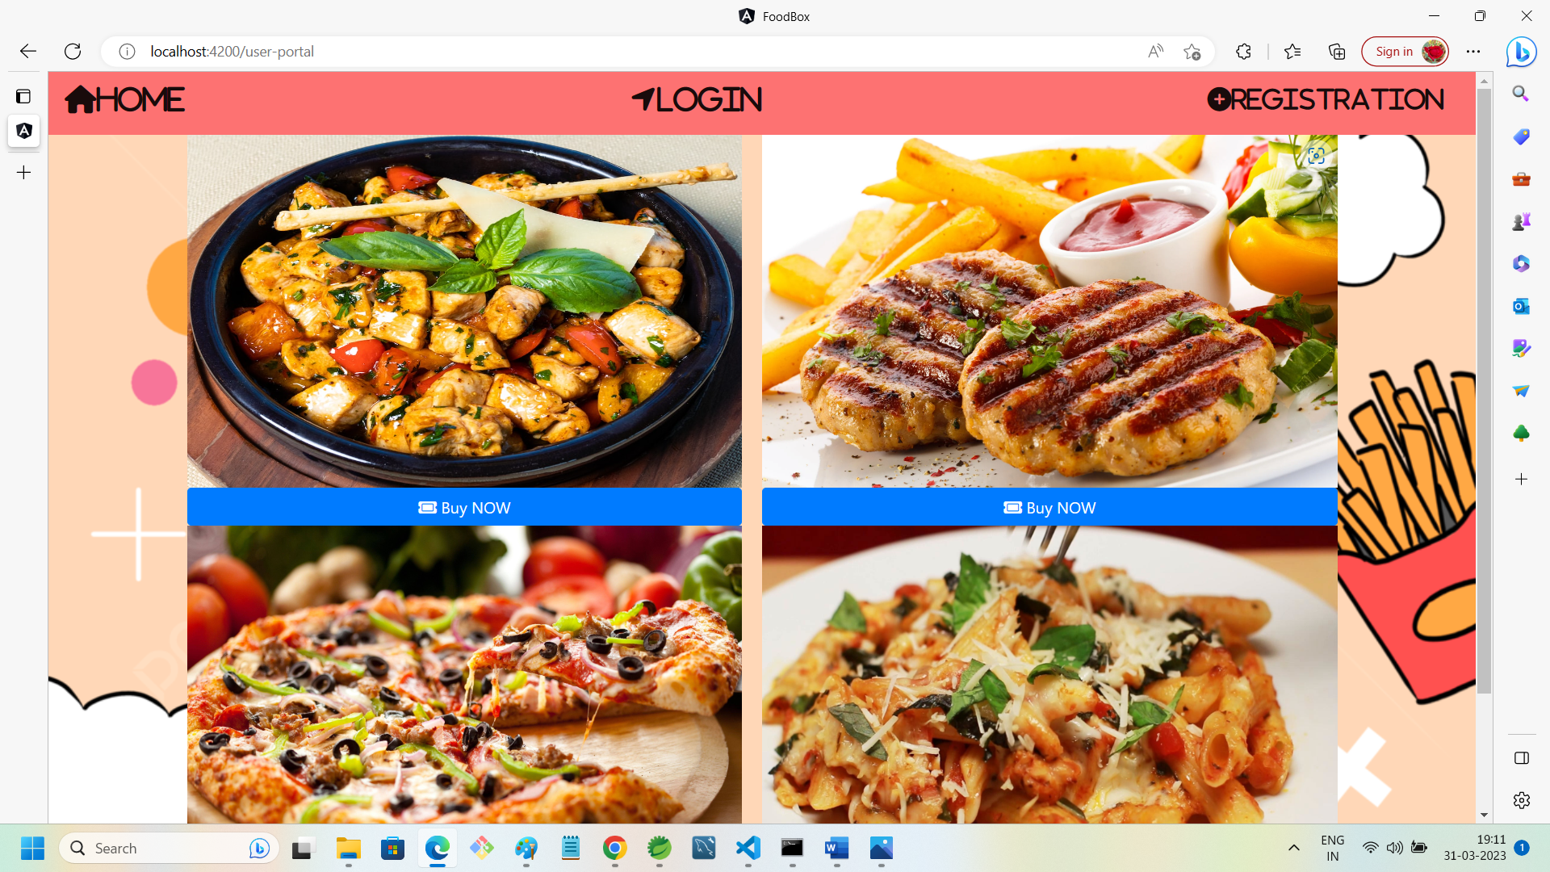

15.USER-PORTAL: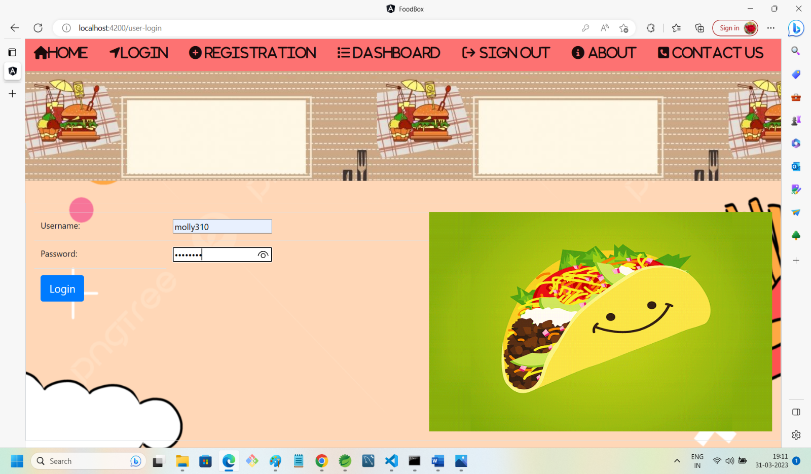

16.USER-DASHBOARD:

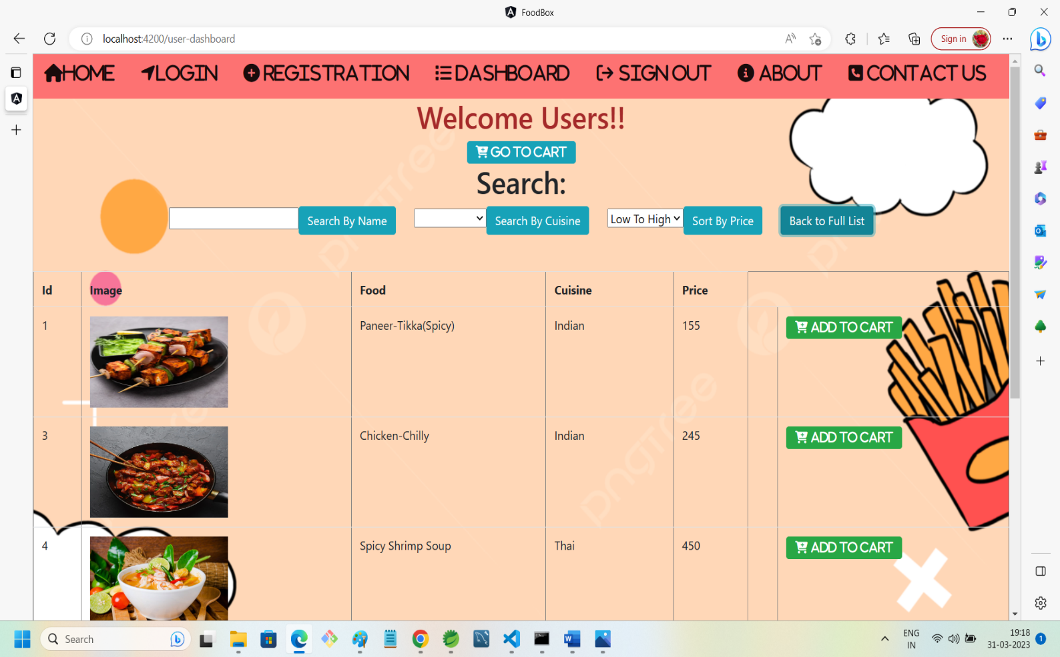

17.SEARCHING FOOD RESULT:

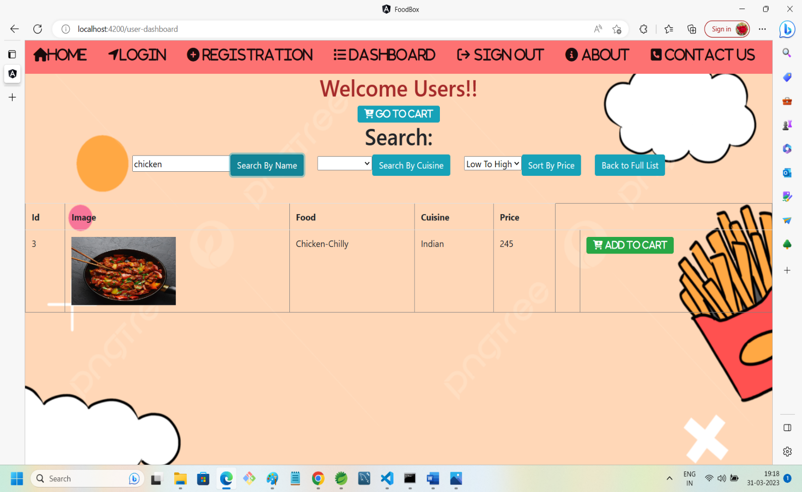

18.FILTERING FOOD WITH RESPECT TO CUISINE:

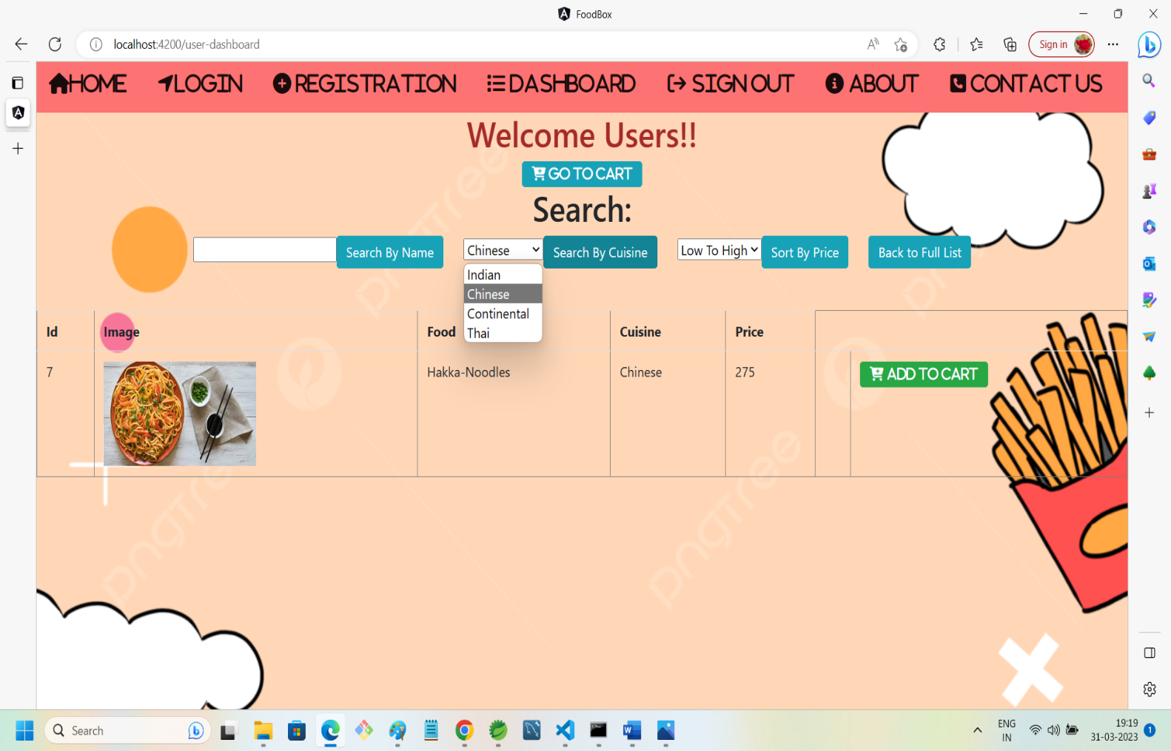

19.SORTING FOOD WITH RESPECT TO ITS PRICE: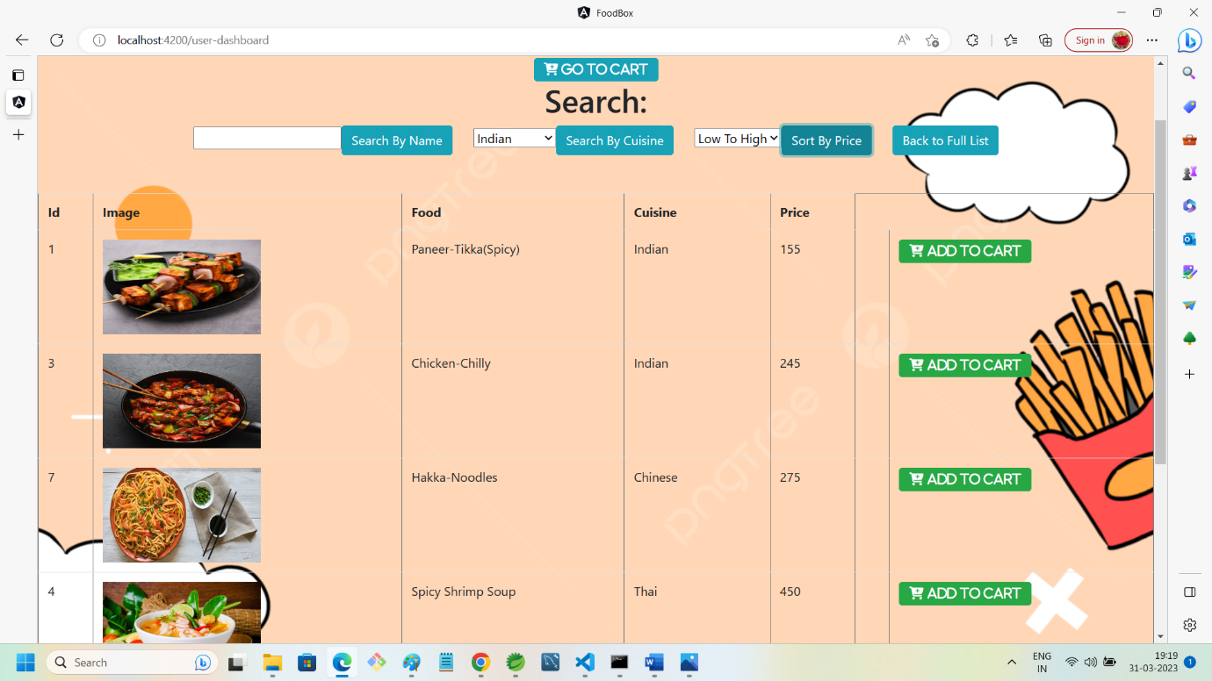

20.ADDING FOOD TO CART:

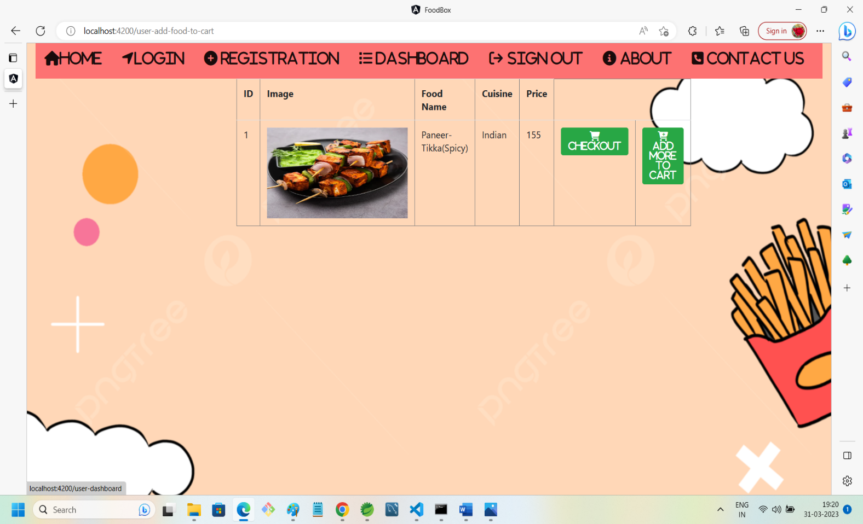

21.PROCEED TO CHECKOUT:

